Context:
This document contains assignments to be completed as part of the hands-on for the day1- week1- iteration1-topic.

Assignment 1: Array

Estimated time: 20 Mins
Problem description: Write an application to store ‘N’ numbers of type integers and sort it using below explained logic. Your program should display the sorted numbers in a formatted way
Example: Let us take the array of numbers "5 1 4 2 8", and sort the array from lowest number to greatest number using bubble sort. In each step, elements written in bold are being compared. Three passes will be required.

First Pass:
( 5 1 4 2 8 ) ( 1 5 4 2 8 ), Here, algorithm compares the first two elements, and swaps since 5
> 1.
( 1 5 4 2 8 ) ( 1 4 5 2 8 ), Swap since 5 > 4
( 1 4 5 2 8 ) ( 1 4 2 5 8 ), Swap since 5 > 2
( 1 4 2 5 8 ) ( 1 4 2 5 8 ), Now, since these elements are already in order (8 > 5), algorithm does not swap them.

Second Pass:
( 1 4 2 5 8 ) | ( 1 4 2 5 8 )
( 1 4 2 5 8 ) | ( 1 2 4 5 8 ), Swap since 4 > 2
( 1 2 4 5 8 ) | ( 1 2 4 5 8 )
( 1 2 4 5 8 ) | ( 1 2 4 5 8 )
Now, the array is already sorted, but our algorithm does not know if it is completed. The algorithm needs one whole pass without any swap to know it is sorted.
Third Pass:
( 1 2 4 5 8 ) | ( 1 2 4 5 8 )
( 1 2 4 5 8 ) | ( 1 2 4 5 8 )
( 1 2 4 5 8 ) | ( 1 2 4 5 8 )
( 1 2 4 5 8 ) | ( 1 2 4 5 8 )

Assignment 2: Type casting and variable length of arrays

Estimated time: 15 Mins
Problem description: Write a program which performs addition of two double arrays, which are variable in size and stores the result in integer array. Display the resultant integer array in a formatted way.

Example:
Input:

dInputArray1[] | 10.0 | 20.0 | 30.0
dInputArray2[] | 20.0 | 50.0 | 30.0 | 70.0 | 80.0

Output:

iSumArray[] | 30 | 70 | 60 | 70 | 80

Assignment 3: Enum Data type

Estimated time: 20 Mins
Problem description: A star hotel would like to display the menu card based on day of a week. Develop an application which uses “enum” data type and switch case to display the menu card of the hotel.
Hint:
- Create a class ‘MenuCard’ having enum type to hold days of the week as
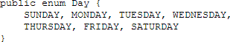

- Use above declared enum variable to display the menu card based on day of week. Sample block of code for ‘Monday’ has been provided below
Day thisday = Day.MONDAY;
switch (thisday)
{
case Day.MONDAY: Console.WriteLine("Dosa"); Console.WriteLine("Idly"); Console.WriteLine("Poori"); Console.WriteLine("Rice-bath"); break;
};

Assignment 4: Class diagram
Problem description: Analyze the below scenario and create an appropriate class diagram:
Assignment 5: Static variable and methods

Estimated time: 20 Mins
Problem description: For the class diagram which is described in assignment number-3, the bank wants to maintain the details of total number of accounts which have been opened.
Modify your code to get the result of total number of accounts which is opened.
Note: Use only static methods to access static variable
Estimated time: 20 Mins
A company requires a payroll system.
The company has three types of employees, namely, a manager, a commission worker, and an hourly worker.
Information that needs to be stored for each employee is the employee’s first name, surname, earnings and employee number.
Additional information that must be stored for a manager is his/her monthly fixed salary; for a commission worker his/her flat salary, sales percent and the sales made for the month; for an hourly worker the number of hours worked and the wage per piece.
Earnings must be calculated for each employee. A manager earns a fixed monthly salary. A commission worker earns a flat monthly salary as well as a percentage of the sales he/she makes for the month. An hourly worker gets paid according to the number of hours worked.
A fixed wage is set per hour. All employees get a medical aid contribution. In addition to this managers get a pension as a fringe benefit. Each medical aid instance specifies the medical aid number, dependent’s, employee contribution and company contribution, while each pension instance specifies the pension number, beneficiaries, amount and date of retirement.

Assignment 5: Class and object
Problem description: Write a program as below guideline:
- Create an Employee class with following attributes:
+EmpDept: String
+EmpDesig: String
+EmpId: int
+EmpName: String
Employee
Estimated time: 20 Mins

- Write a program, which creates an instance of employee class and sets the values for all the attributes.

  - While setting value for empName, method should check for NullPointer and display appropriate error message.

  - While setting value for empDesig, the designation must have any of the following values: developer, tester, Lead or manager. If none of these values is matching then setter method should display 'Invalid designation' error message.

  - While setting value for empDept, the department must have any of the following values: C2, TTG, ITES or PES. If none of these values is matching then setter method should display 'Invalid Dept' error message.

Assignment 6: Array of objects

Estimated time: 20 Mins
Problem description: A coffee shop would like to find out the customer feedback rating about its services. The customer class shown below:
+FeedbackRating: double
+MobileNumber: String
+Name: String
Customer

Example: Assume that the shop will collect feedback from ‘N’ customers. Following are the sample customer feedback values.
Customer 1: 3 out of 5
Customer 2: 4 out of 5
Customer 3: 2.5 out of 5
Write an application which creates array of ‘N’ customer objects to store feedback values of these customers and print the average feedback rating.

Assignment 7: Method which returns an object value

Estimated time: 25 Mins
Problem description: An agency which works for a bank takes care of background verification of a customer who had applied for a personal loan. The agency will go through background check and classify the customer into two categories: “Green” and “Red”.

Example:
If a customer has good financial transaction history, he/she will be categorized as “Green”. If a customer has poor financial transaction history, he/she will be categorized as ‘Red”.
Based on category, the bank will decide to approve the loan request. Below is the class diagram.
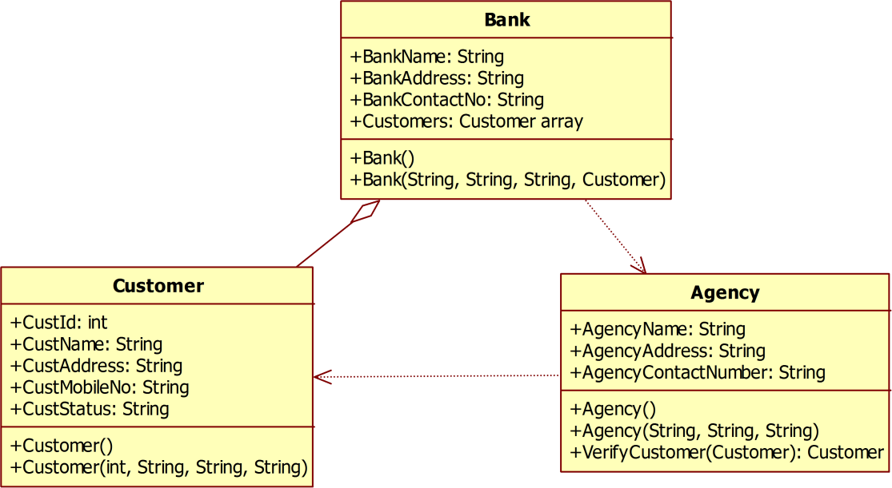
Write an application which implements above scenario: The class “Agency” has method called: VerifyCustomer(Customer), which accepts Customer object as an argument, changes the status of “CustStatus” either to “Green” or “Red”. Return the updated Customer object.
Note: The initial value of “custStatus” of Customer class must be “null”.

Assignment 8: Static methods

Estimated time: 15 Mins
Problem description: Below code is giving some compilation error. Analyze it and remove the error.
int input1,input2,output; static void Main(string[] args)
{
input1=20; input2=40;
output=input1*input2; Console.WriteLine(output);
}

Extend the program to add static methods Add,Subtract,Divide,Multiply to create a calculator.
Assignment 9: Constructor overloading

Estimated time: 20 Mins
Problem description: XYZ bank wants to maintain customer details. It will register the customer details whenever a person opens an account with the bank. Below is the customer class diagram:
+AccType: String
+CustAddress: String
+CustBalance: double
+CustName: String
+CustId: int
Customer

At times, the customer registration process changes, here are the guidelines:
- Admin may register customer by filling only ID, name and address details

- Admin may register customer by filling only ID and name
- Admin may register customer by filling all the details.
Write an application which implements above scenarios. Write main method in separate class, which creates different customer objects and invokes appropriate constructors, here is sample code:
Note: When other data members are not initialized through constructors, they should have appropriate default values.

Assignment 10: Inheritance and method overriding

Estimated time: 25 Mins

Problem description: Write an application which implements following UML diagram. Test your application by creating appropriate objects.




Shape
+Color: String
+Filled: Bool
+ToString(): string

Rectangle
+Length: int
+Width: int
+GetArea(): double
+GetPerimeter(): double
+ToString(): string
Square
+ToString(): string

Circle
+Radius: int
+GetArea(): double
+GetPerimeter(): double
+ToString(): string


Note:
- toString() method should display appropriate class name along with area of shape, when invoked with respective derived class objects.
- In case of parent class ‘Shape’, toString() method should return only class name
- For Shape class, default color is ‘red’, default value for filled is ‘true’. For Circle class, default radius is 1.0. For Rectangle class, default width and length is 1.0
Test your application by writing separate class called ‘TestShapes’, which implements main() method for creating Shape’s objects and invoking its methods. Below is the sample code:
Circle shape1 = new Circle(); shape1.Radius = 5; Console.WriteLine(shape1);

Rectangle shape2 = new Rectangle(); shape2.Width = 5;
shape2.Length = 6; Console.WriteLine(shape2);

Assignment 11: Static methods,properties and classses

Estimated time: 20 Mins
Problem description: For the class diagram given below, company would like to get count on number of employees who are currently on boarded. Employees property is an array of type Employee. Write an application which implements this requirement
+EmpDesign: String
+EmpId: int
+EmpName: String
+EmpCount: int
+Employees: Employee
Employee
Company

Note: Assume that Employees property can have maximum of 100 Employee
Example: Following kind of output is expected

Assignment 12: Method overloading

Estimated time: 20 Mins
Problem description: Codes in boxes below generate error. Analyze the code and debug it. Read the method overloading guidelines:
class Program
{
void display(double x, int y)
{
Console.WriteLine(y);
}
void display(int x, string y)
{
Console.WriteLine(y);
}

string display(double y, int x)
{
Console.WriteLine(y);
}
static void Main(string[] args)
{
Program p = new Program(); p.display(10, “20”);
}
}

class Program
{
void display(double x, int y)
{
Console.WriteLine(y);
}
void display(int x, string y)
{
Console.WriteLine(y);
}

void display(int x, double y)
{
Console.WriteLine(y);
}
static void Main(string[] args)
{
Program p = new Program(); p.display(10, 20);
}
}

Assignment 13: Comparing objects

Estimated time: 30 Mins
Problem description: A college admin would like to compare students of two batches based on their semester total score.
Create class called StudentComparison.cs to implement
- boolean compareStudents(Student batch1*+, Student batch2*+); This will return “true” when both array of objects are equal otherwise it returns “false”
- main() method which creates StudentComparison class and invoke compareStudents() method.
- Comparison has to be done for ‘SemesterTotalScore’ which of datatype double Below is the Student class diagram. Override the equals() method to compare two objects.
+SemesterTotalScore: decimal
+StudentCourse: string
+StudentId: iint
+StudentName: string
+Equals(obj): bool
Student

Assignment 14: Constructor Chaining

Estimated time: 15 Mins
Problem description: Execute the below code and observe the output. Answer the following question. When we execute above code what could be the order of execution of constructor?
class Employee
{
public Employee()
{
Console.WriteLine("Employee class");
}

public Employee(string displayString)
{
Console.WriteLine(displayString);
}
}

class Manager : Employee
{
public Manager()
{
Console.WriteLine("Manager class");
}

public Manager(string displayStringMgr, string displayStringEmp):base(displayStringEmp)
{
Console.WriteLine(displayStringMgr);
}
}

class Program
{
static void Main(string[] args)
{
Manager mgr = new Manager("Manager class, overloaded constructor","Employee class, overloaded constructor");
Manager newmgr = new Manager(); Console.Read();
}

}

Estimated time: 20 Mins
Problem description: Create class library and place the classes which are given in the below class diagram in corresponding namespace:
- Namespace Name: com.mindtree.Bank
Classes Name: Account, LoanAccount, SavingsAccount and FixedDeposit
- Namespace Name: com.mindtree.Customers Class Name: Customer
- Namespace Name: com.mindtree.TestCustomers Class Name: TestCustomer
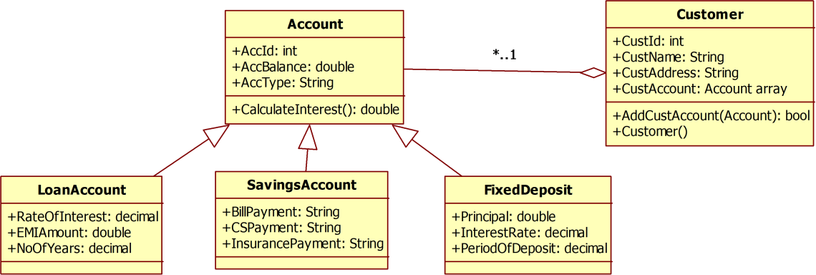

Assume that a customer cannot have more than 20 account.
AddCustAccount returns false if total number of accounts for the customer has reached 20.
Write main method inside the class ‘TestCustomer’ and create the object of ‘Customer’ class to invoke its methods.

Assignment 15: Abstract Class

Estimated time: 25 Mins
Problem description: In an organization, the salary component varies from an employee to employee. Below is the class diagram which depicts different types of an employee. An abstract class called ‘Employee’ has an abstract method ‘calculateSalary()’, which must be overridden in each of derived classes: Trainee, TeamLead and Manager.
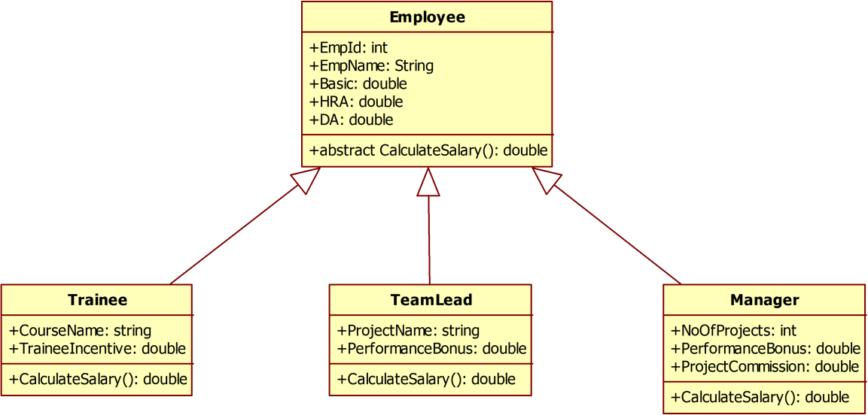

Each employee will have common salary components: Basic, DA and HRA, other components vary among different employees.

Example:
- For a team lead, salary will be calculated as: Basic+HRA+DA+performanceBonus
- For a manager, salary will be calculated as: Basic+HRA+DA+performanceBonus+projectCommission
- For a trainee, salary will be calculated as: Basic+traineeIncentive
Write an application which implements above scenario and write main method to test your code.

Assignment 16: Interface

Estimated time: 30 Mins
Problem description: Implement the following mobile tariff plan class diagram and test it using separate class:
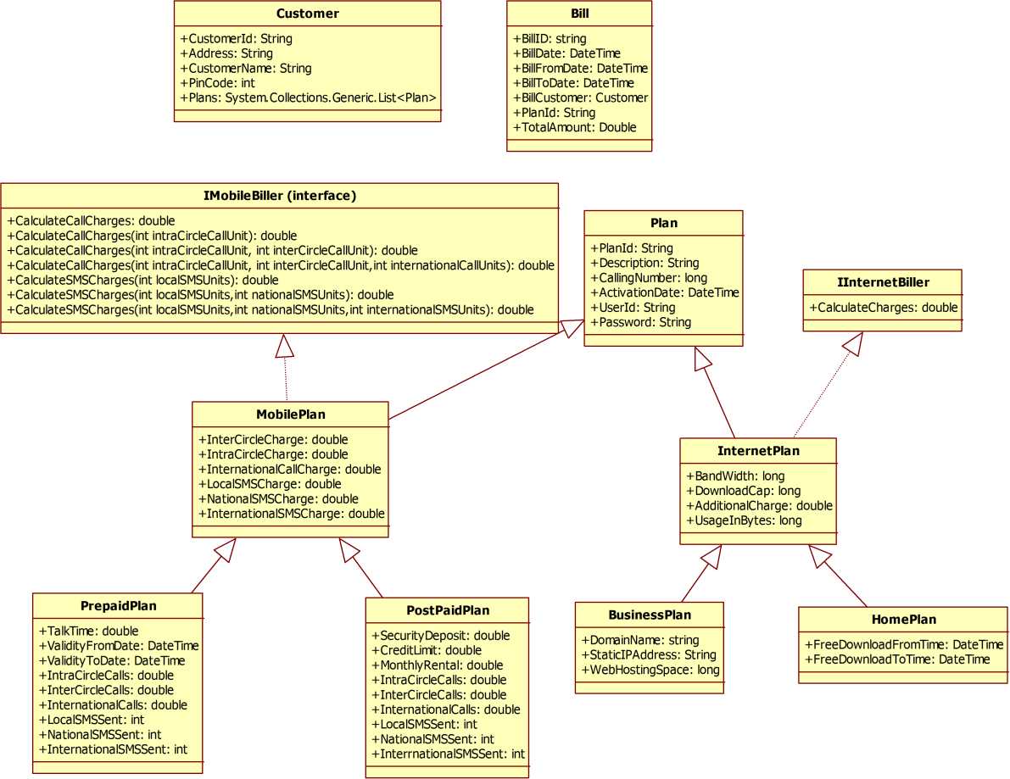

Assignment 17: Understanding exception handling

Estimated time: 20 Mins
Problem description: Write an application which has a method, which accepts employee’s mobile number as string and validates with respect to following instructions:
- String length should be 10 characters
- String should have only digits
- String should always start with digit ‘9’
Note: The method also should take care of “Null pointer exception”

Assignment 18: Understanding Finally block

Estimated time: 20 Mins
Problem description: Below code is having some mistake. Can you rectify the mistake:
try
{
StreamReader sr = File.OpenText("C://abc.txt"); int input1,input2,output;
input1 = int.Parse(sr.ReadLine()); input2 = int.Parse(sr.ReadLine()); output = input1 / input2; sr.Close();
}
catch (OverflowException ex)
{
throw ex;
}
catch (DivideByZeroException ex)
{
throw ex;
}

Correct the program to handle all runtime-exceptions:
- invalid values in abc.txt
- DividebyZero
- Overflow
Assignment 19: Custom exception

Estimated time: 20 Mins
Problem description: Write a class ClsVehicle as shown in the class diagram below:
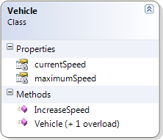

Write a custom exception class as given in the class diagram:
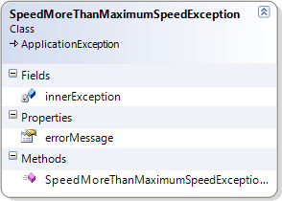

Invoke the Vehicle class maximumSpeed method from main() to catch SpeedMorethanMaximumSpeedException

Summary of assignments:
You have learnt
  - How to process arrays
  - How to create variable parameter lists
  - How to do explicit type casting
  - How to use enum data type variables
  - How to process command line arguments
  - How to analyze the class diagrams
  - How to create class and objects
  - How to create array of objects
  - How to pass an object as an argument
  - How to return an object from a method
  - How to overload constructors
  - How to implement method overriding
  - Usage of static keyword
  - How to compare two objects
  - How to implement constructor chaining
  - How to implement packages in .NET
  - How to implement abstract class
  - How to implement interface
  - How to implement try catch block
  - How to use throw and throws keyword
  - How to use finally block
  - How to define user defined exceptions

